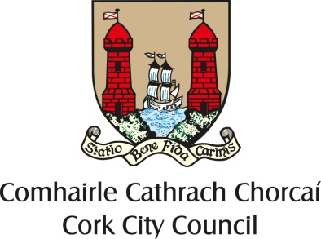

COMHAIRLE CATHRACH CHORCAÍ
CORK CITY COUNCIL

Tel. (021) 4924586

TWINNING GRANT APPLICATION FORM 2022

All Twinning Grant Application Forms must be completed and e-mailed to the International Relations Officer i.e. Gillian_Lucas@corkcity.ie no later than
5.00 p.m. on Friday, 11th February, 2022.

Name of Twinned City Links Are To Be Developed With: .......................................

Name of Organisation/Group/Individual:

..................................................................................... ...................................... ........

Name of Organiser: ....................................................................................................

Contact Address:.........................................................................................................

.....................................................................................................................................

.....................................................................................................................................

Contact Telephone No.:...............................................................................................

Objective of Organisation/Group/Individual: ........................................... ...............

.....................................................................................................................................

.....................................................................................................................................

Membership of Organisation/Group

(Age, Nos., etc.) :.........................................................................................................

.....................................................................................................................................

Activities of Organisation/Group:................................................................................

.....................................................................................................................................

Detailed Description of the Proposed Activity: (further information can be provided on a separate sheet).
.....................................................................................................................................

.....................................................................................................................................

.....................................................................................................................................

.....................................................................................................................................

.....................................................................................................................................

.....................................................................................................................................

Dates of the Proposed Activity:……………………………….....................................

.....................................................................................................................................

Number taking part in Proposed Activity: ...................................................................

.....................................................................................................................................

Description of any previous experience of Twinning Activities: ...............................

.....................................................................................................................................

....................................................................................................................................

....................................................................................................................................

....................................................................................................................................

....................................................................................................................................

....................................................................................................................................

Financial Projection of Proposed Twinning Event:

ORGANISATION/RECEPTION/TRAVEL COSTS

EXPENDITURE – HOST/GUEST GROUP | €
Programme/Organisation

Accommodation

Travel

Other (Specify)

TOTAL EXPENDITURE

INCOME – HOST/GUEST GROUP | €
Grant from Local/Regional Authority

Grant from European Commission

Contribution from Participants

Other Revenue

TOTAL INCOME

Name: ................................................... Signature:.....................................
(Organisation stamp)
Date: .....................................................

CONDITION OF GRANTS

- Any organisation/group/individual located or providing services within the administrative area of Cork City Council that proposes to promote the twinning links between Cork City and any of the twinned cities may apply for a grant.

- The nature of the activity may be community based, voluntary, social, cultural, educational, and sporting or of general social and economic benefit.

- The activity may involve travelling to/from a twinned city but travel is not a
pre-requisite for awarding a grant. Please note any travel restrictions which are in place due to Covid-19.

- An activity which is likely to develop and deepen links and generate new contacts with a twinned city will be given extra consideration.

- Twinning Grants are awarded annually and cover the period January-December. The activity must take place within the calendar year specified.

- The maximum grant awarded will be no more than 50% of the total cost. The grant payable will be based on 50% of receipts submitted on completion. (Note: The award figure may differ from the actual grant paid). Funding will be dependent on the number of applications received and subject to terms and conditions. All applications must be supported by detailed programmes and financial projections.

- The decision on allocation of amounts of grants is made by the elected members at a meeting of Council of Cork City Council.

- The closing date for receipt of applications for grants is determined annually by the International Relations Committee.

- Prior to payment of any award a written report on the completed activity along with receipts showing proof of expenditure must be submitted to Cork City Council.

- Cork City Council to be acknowledged through any promotional material produced.

N.B. In response to Covid-19, all applicants must comply with all relevant National Guidelines and Restrictions.

TWINNED CITIES: - Rennes, France
Cologne, Germany
San Francisco, U.S.A.
Coventry, England
Swansea, Wales
Shanghai, China

